Code structure description

The project is divided into 2 levels. In high level.

In high level, we have many assets. Script folder has all code. Scene folder has all play scenes.

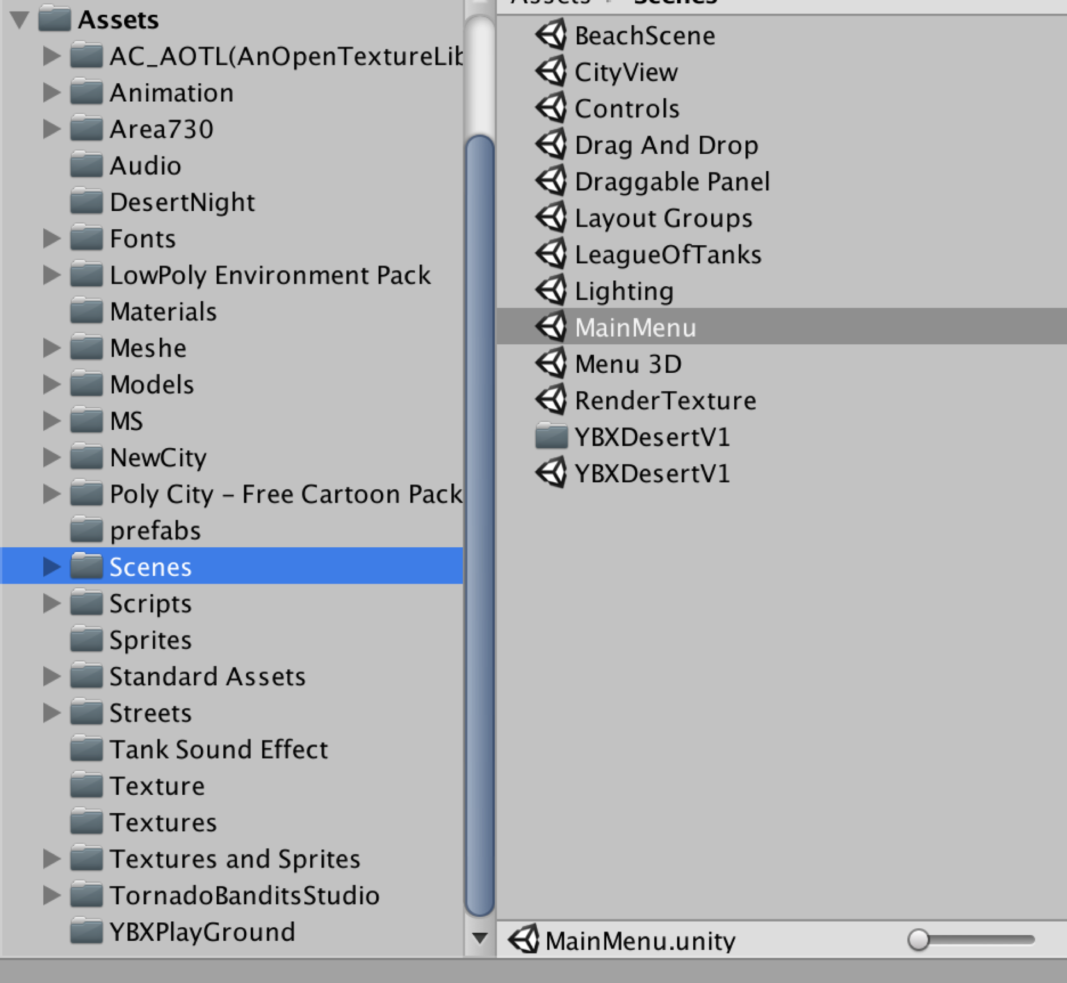

For the script folder,

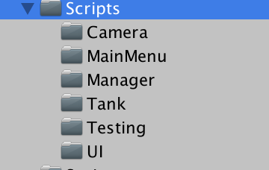

It has Camera (Control the game camera), MainMenu (Show the main menu), Manager (Realize the OOD and design pattern, e.g. factory design pattern will reuse tank objects), Tank has tank object code. Testing for test code. UI for health slider direction control.

In the “Models” folder, it contains all the prefabs this game needs. For example, tank, shell etc. Once a new game starts, the game manager will create game objects on the map by using these prefabs.